# Stack Tools

## Purpose

This module offers a set of functions for image stacks. These functions are:

* Simple stacking of layers from multiple files into a single image stack
* Unstacking an image stack into its separate layers
* Aggregate values in an image stack by location; supported aggregations are sum, mean, median, min and max
* Stack statistics: calculates basic statistics by location; supported are sum, mean, standard deviation, coefficient of variation, min and max
* Remove bias by taking the mean from a reference image stack by location and subtracting this mean from the mean of the target stack. The target stack is then corrected by subtracting the bias from all the individual layers

## Installation

Install the .sav files in the save_add folder (see also [ENVI .sav files: Installation and configuration](http://www.itc.nl/personal/nieuwenh/installations.html).

nrs_Utils.sav Library with utility routines

nrs_stack_tools.sav The actual software

## Usage (gui)

|  |  |
| --- | --- |
| NRS_Stack_gui | Start the user interface of the stacking. |
| NRS_UnStack_gui | Start the user interface of the unstacking. |
| NRS_Aggregate_gui | Start the user interface of the aggregation. |
| NRS_Stack_Statistics_gui | Start the user interface of the stack statistics. |
| NRS_Bias_Removal_gui | Start the user interface of the bias removal. |

Alternatively the commands can be started from the ENVI menu: ‘NRS | Stack’:

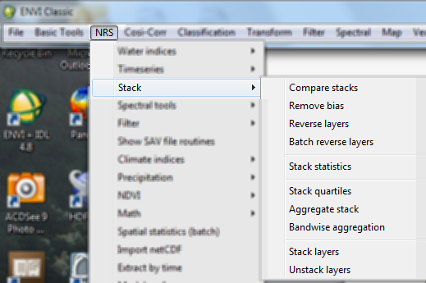

### Stacking

Menu option is ‘NRS | Stack | Stack layers’, the command line is ‘nrs_stack_gui’. This is a simpler function than the ENVI built-in layer stacking option. All input layers must have the same dimensions (rows and columns), the coordinate system is assumed to be the same (it is copied from the first layer to be stacked). The layers are simply stacked (in BSQ) without resampling. Below is the user interface.

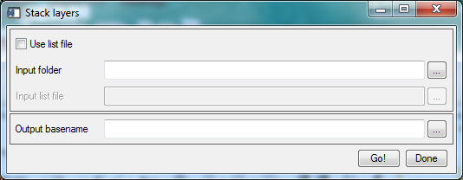

There are two options to initiate the stacking:

|  |  |
| --- | --- |
| Folder (Use file list not checked) | Select a folder: all ENVI files are scanned and used for stacking. The files are ordered alphabetically before the stacking, so the layer order is determined by this! |
| List file (Use file list checked) | Select a text file containing the layers to stack. The files are stacked in the order in which they appear in the list file. This gives more control to the user with respect to the order in which the layers are stacked. Also this option allows all image file recognized by ENVI as input. |

### Unstacking

Menu option is ‘NRS | Stack | Unstack layers’, the command line is ‘nrs_unstack_gui’. This is a simple command to extract all layers into separate files. Each file will be assigned the output base name with a number appended as the filename; the number increases for each file. No check is made on duplicate layer names. The layer name is copied to the output file as layer name. The output files are ENVI image files. Also the software creates a text file containing the names of the extracted layers. This can then for example be used as input for the above mentioned stacking command as the list file. This text file gets the base name of the output file.

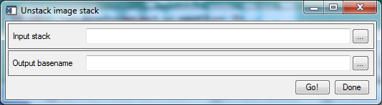

### Aggregate stack

Menu option is ‘NRS | Stack | Aggregate stack’, the command line is ‘nrs_aggregate_gui’. This command will on a per pixel basis aggregate the values in the stack. The output is an ENVI image with either a single layer (if one aggregation method is selected) or 5 layers (if the aggregation method ‘All’ is selected). The available aggregation methods are sum, mean, median, min and max, and the option ‘All’ to select them all at once.

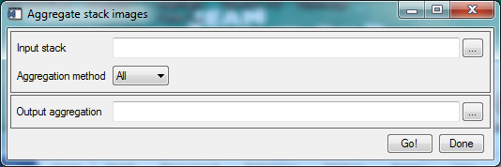

The output is an ENVI image. The layers get band names according to the aggregation method.

### Stack Statistics

Menu option is ‘NRS | Stack | Stack statistics’, the command line is ‘nrs_stack_statistics_gui’. This command will on a per pixel basis calculate the statistics of the values in the stack. The output is an ENVI image with 5 layers, one for each of the statistics. The following statistics are calculated: mean, standard deviation, coefficient of variation, min and max. The layer names indicate the statistics value in that layer.

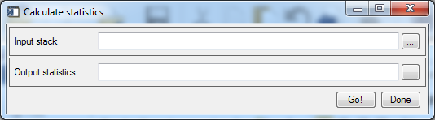

Explanation of the fields:

|  |  |
| --- | --- |
| Input stack | The input stack for the statistics calculation. |
| Output statistics | Name for the output statistics stack |

The statistics are calculated for each location (pixel).

Mean: $μ=\frac{\sum_{i=1}^{n}{x_{i}}}{n}$

Standard deviation: $σ=\sqrt{\frac{1}{n}\sum_{i=1}^{n}{{\left(x_{i}-μ\right)}^{2}}}$

Coefficient of variation: $C_{v}=σ/μ$

### Bias removal

Menu option is ‘NRS | Stack | Bias removal’, the command line is ‘nrs_bias_removal_gui’. This command will on a per pixel basis calculate the mean of the values in the reference stack. Again on a per pixel basis the bias value is then subtracted from all layers in the input target stack. The output is an ENVI image stack, with the same layer names as the target stack.

